DHA Health Data Protection Regulation Compliance for Log360
Tagline: Meet Dubai Health Authority's regulatory expectations with unified log monitoring from Log360.

Overview
The DHA Health Data Protection Regulation Compliance extension for Log360 enables Dubai healthcare facilities and digital health operators licensed by the Dubai Health Authority to meet DHA's requirements for securing protected health information, maintaining access audit trails, and responding to security incidents.
Log360 collects logs from clinical systems, databases, cloud platforms, and network devices, correlating events to surface risks to patient data confidentiality and system integrity. Security and compliance teams can continuously monitor compliance status, investigate suspected breaches, and deliver audit-ready documentation to DHA regulators.

Key Features
- Generate DHA-aligned audit reports covering protected health information access events, user authentication logs, and system integrity monitoring.
- Detect unauthorized access to patient records using real-time correlation rules and ML-powered anomaly detection across clinical IT environments.
- Track database queries, cloud storage access, and file movements involving health data to identify potential privacy violations.
- Export compliance reports in PDF and CSV formats for DHA regulatory submissions and internal data protection committees.

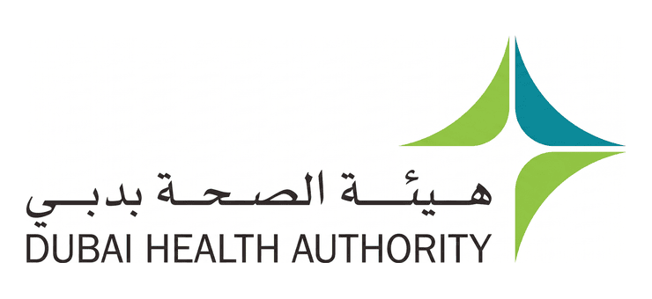

Screenshots
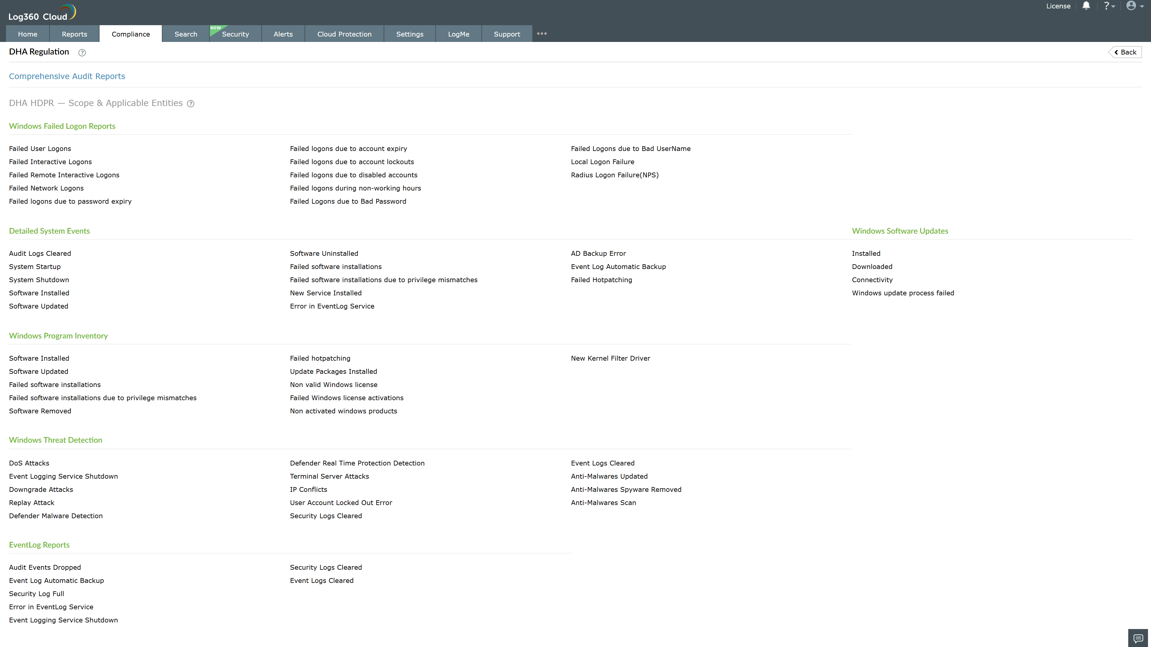
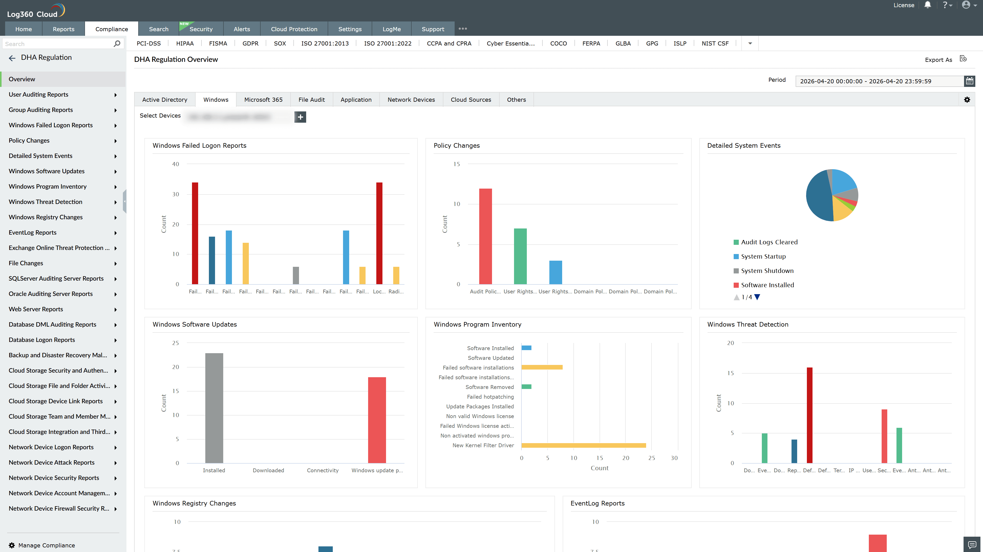
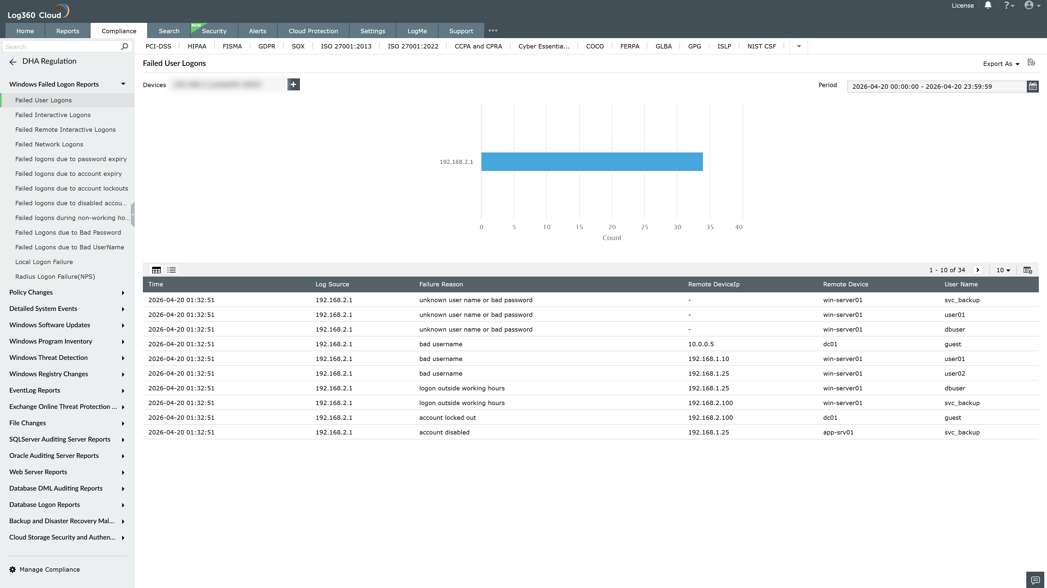
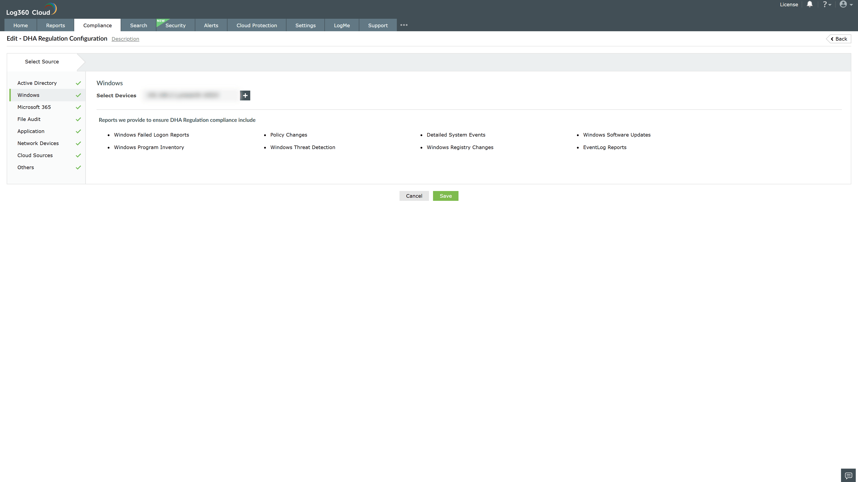

Valid Submission : Yes
Supported Editions : Free, Basic, Standard, Professional, MSSP
Help Document : https://www.manageengine.com/log-management/help/integrations/compliance-extensions.html
Help Video : Not provided
Tags : Log360, Compliance, Privacy monitoring, Data privacy, Regulatory compliance
Supported DCs : US, IN, JP, CA, AU, UK and EU
Privacy Policy:
Terms of Service:
Release Notes:
Predefined reports for the DHA Health Data Protection Regulation Compliance

